**Lab 8 Assignment Submission**

*Yash Srivastava*  
*220962368*  
*11/03/2025 (****Lab 8 Assignment****)*

**1. User Registration Form with CSRF Protection  
2️. User Voting System for Book Review  
3️. CGPA Calculator Using Django Sessions  
4. Billing System for Electronics Purchase  
5. Courseware Feedback Form**

**Project Structure:**

Lab8/

│── manage.py

│── Lab8/ # Main project settings

│ ├── __init__.py

│ ├── settings.py

│ ├── urls.py

│ ├── wsgi.py

│

├── register/ # App for registration form

│ ├── migrations/

│ ├── templates/

│ │ ├── register.html

│ │ ├── success.html

│ ├── __init__.py

│ ├── views.py

│ ├── urls.py

│

├── voting/ # App for user votes

│ ├── migrations/

│ ├── templates/

│ │ ├── vote.html

│ │ ├── result.html

│ ├── __init__.py

│ ├── views.py

│ ├── urls.py

│

├── cgpa/ # App for cgpa calculation

│ ├── migrations/

│ ├── templates/

│ │ ├── input.html

│ │ ├── result.html

│ ├── __init__.py

│ ├── views.py

│ ├── urls.py

**Lab8/settings.py:**

INSTALLED_APPS = [

…

'register’,

'voting',

'cgpa',

]

**Lab8/urls.py:**

from django.contrib import admin

from django.urls import path, include

urlpatterns = [

path('admin/', admin.site.urls),

path('register/', include('register.urls')),

path('vote/', include('voting.urls')),

path('cgpa/', include('cgpa.urls')),

]

**User Registration Form (App: register)**

**register/views.py:**

from django.shortcuts import render

from django import forms

def register_view(request):

if request.method == 'POST':

form = RegisterForm(request.POST)

if form.is_valid():

request.session['user_data'] = form.cleaned_data

return render(request, 'success.html', {'user_data': form.cleaned_data})

else:

form = RegisterForm()

return render(request, 'register.html', {'form': form})

def success_view(request):

user_data = request.session.get('user_data', {})

return render(request, 'success.html', {'user_data': user_data})

**register/forms.py:**

from django import forms

class RegisterForm(forms.Form):

username = forms.CharField(label="Username", required=True, max_length=100)

password = forms.CharField(widget=forms.PasswordInput(), required=False)

email = forms.EmailField(required=False)

contact = forms.CharField(label="Contact Number", required=False, max_length=15)

**register/urls.py:**

from django.urls import path

from .views import register_view, success_view

urlpatterns = [

path('', register_view, name='register'),

path('success/', success_view, name='success'),

]

**register/templates/register.html:**

<!DOCTYPE html>

<html>

<head>

<title>Register</title>

</head>

<body>

<h2>Register</h2>

<form method="post">

{% csrf_token %}

{{ form.as_p }}

<button type="submit">Submit</button>

</form>

</body>

</html>

**register/templates/success.html:**

<!DOCTYPE html>

<html>

<head>

<title>Success</title>

</head>

<body>

<h2>Welcome {{ user_data.username }}</h2>

<p>Email: {{ user_data.email }}</p>

<p>Contact: {{ user_data.contact }}</p>

</body>

</html>

**Voting System (App: voting)**

**voting/views.py:**

from django.shortcuts import render

votes = {'good': 0, 'satisfactory': 0, 'bad': 0}

def vote(request):

if request.method == "POST":

choice = request.POST.get("choice")

if choice in votes:

votes[choice] += 1

total_votes = sum(votes.values())

percentages = {key: (value / total_votes) * 100 if total_votes > 0 else 0 for key, value in votes.items()}

return render(request, "result.html", {"percentages": percentages})

return render(request, "vote.html")

**voting/templates/vote.html:**

<form method="post">

{% csrf_token %}

<p>How is the book?</p>

<input type="radio" name="choice" value="good"> Good

<input type="radio" name="choice" value="satisfactory"> Satisfactory

<input type="radio" name="choice" value="bad"> Bad

<button type="submit">Vote</button>

</form>

**voting/templates/result.html:**

<p>Good: {{ percentages.good }}%</p>

<p>Satisfactory: {{ percentages.satisfactory }}%</p>

<p>Bad: {{ percentages.bad }}%</p>

<a href="/vote/">Vote Again</a>

**voting/urls.py:**

from django.urls import path

from .views import vote

urlpatterns = [

path('', vote, name='vote'),

]

**CGPA Calculation (App: cgpa)**

**groceryapp/views.py:**

from django.shortcuts import render

def grocery_list(request):

groceries = {'Wheat': 40, 'Jaggery': 60, 'Dal': 80}

selected_items = {}

if request.method == 'POST':

selected_items = {item: price for item, price in groceries.items() if item in request.POST}

return render(request, 'groceryapp/grocery_list.html', {'groceries': groceries, 'selected_items': selected_items})

**groceryapp/templates/groceryapp/grocery_list.html:**

<form method="POST">

{% csrf_token %}

<h3>Select Items:</h3>

{% for item, price in groceries.items %}

<input type="checkbox" name="{{ item }}"> {{ item }} - ₹{{ price }}<br>

{% endfor %}

<button type="submit">Add Item</button>

</form>

{% if selected_items %}

<h3>Selected Items:</h3>

<table border="1" style="border-collapse: collapse;">

<tr>

<th>Item Name</th>

<th>Item Price</th>

</tr>

{% for item, price in selected_items.items %}

<tr>

<td>{{ item }}</td>

<td>₹{{ price }}</td>

</tr>

{% endfor %}

</table>

{% endif %}

**groceryapp/urls.py:**

from django.urls import path

from .views import grocery_list

urlpatterns = [

path('', grocery_list, name='grocery_list'),

]

**Screenshot of car manufacturer selection at http://127.0.0.1:8000/carapp/**

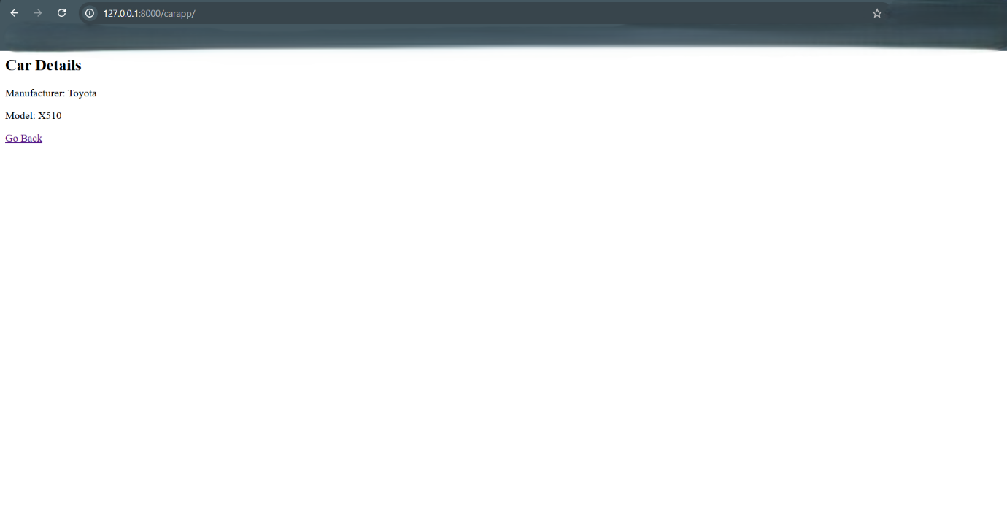

**Screenshot of session-based navigation at** [**http://127.0.0.1:8000/sessionapp/**](http://127.0.0.1:8000/sessionapp/)

**Screenshot of grocery checklist at** [**http://127.0.0.1:8000/groceryapp/**](http://127.0.0.1:8000/groceryapp/)

